ELEC 2210 LABORATORY REPORT COVER PAGE

Please Let Me Know if I keep having to include this page and edit it or can I use the Title Page I made below right after this page. Comment on canvas. Thanks

Meeting # 002 Experiment 1: Basic Digital Logic CIrcuits

*Title of Lab Experiment*

Student Name: Howard Jacob, A

*Name (Last, First, MI)*

Student Email: JAH0147

*AU 7-character username*

GTA: Jonathan

*Name of your GTA*

Section you are enrolled in: (Circle One): 1 2 3 4 5 6 7 8

Date experiment performed (dd / mm / yy): *13/10/20*

Date report submitted: (dd / mm / yy): *20/10/20*

If you performed this experiment at a time other than your regularly scheduled section meeting:

Section # of the section you sat in on (Circle One): 1 2 3 4 5 6 7 8 Makeup

Name of the GTA who supervised your work: __________________________

I hereby certify that the contents of this report are true and complete to the best of my ability. The lab work was performed by me exclusively, and this report was written by me exclusively.

*Jacob Howard* 20/10/20

Student signature Date signed

ELEC-2210

Digital Electronics

FROM: Jacob Howard

TO: Yili “Jonathan” Wang

LAB DATE: 10/13/20

DUE DATE: 10/20/20

LAB SECTION: 002 (Tuesday, 1:00pm-2:50 pm)

EXPERIMENT 8:

Free Space Optical Communication Link

# **Introduction**

# For this week’s laboratory experiment we used new components and experimented with different waves. By using Infra-Red LEDs and a photo transistor detector, we experienced free space communication. This helped us to complete different circuits. We also experienced with AM, FM and ARB waves to try different circuits.

# **Step 1**

This laboratory experiment was formed by 5 different parts. Step 1 had two subsections. In this first one, we connected the IR LED to the DUT+ and DUT- ports and measured the I-V characteristics of it. The screenshot obtained is shown in *Figure 1*. To produce 15mA of current it is necessary to supply around 1.2V.

For the second section in Part 1, we added a 510 Ω resistor in series with the IR LED and repeated the same process as in the first section. The screenshot is shown as *Figure 2.*

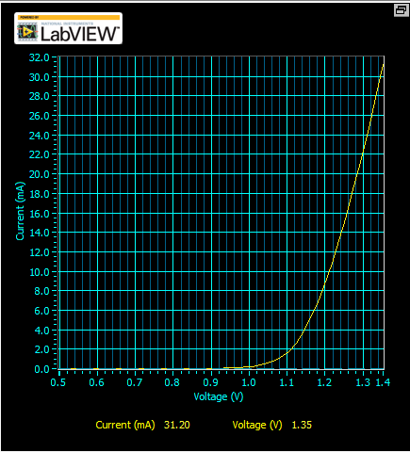

*Figure 1*

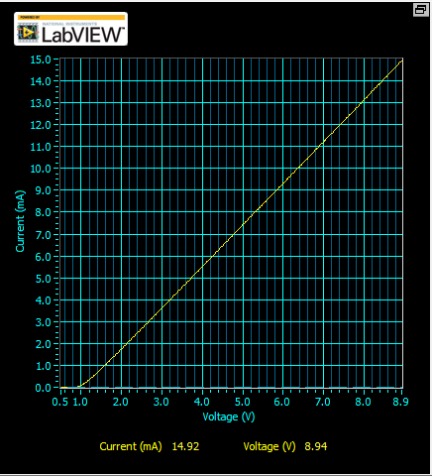

*Figure 2*

# **Step 2**

# For Part 2, we left the resistor and IR LED combo connected to the board but this time we added the photo transistor fairly close to the LED. The screenshots taken are when current is approximately 5mA, shown in *Figure 3* and 10mA shown in *Figure 4*. The voltage required for these values are around 4 V and 6 V, respectively.

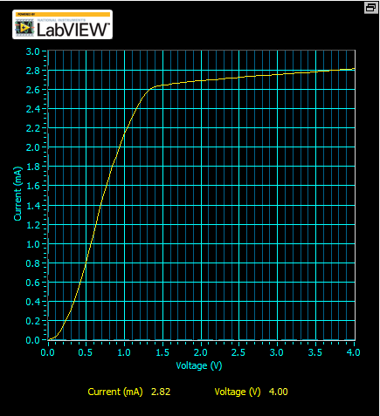

*Figure 3*

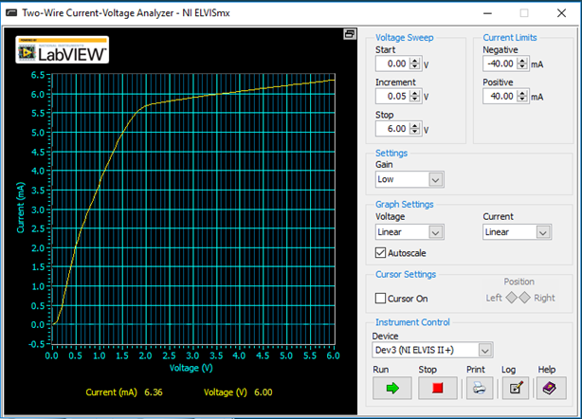

*Figure 4*

# **Step 3**

For Step 3, we constructed the circuit shown in the lab manual and set the function generator with the provided settings at around 500 Hz. The signal I received for the first part is shown in *Figure 5.* Next, we played with the DC offset to find distortion, which is shown in *Figure 6.* Finally, we were to block the IR signal. The graph of the blocked signal is shown in *Figure 7*. After doing all three steps, we were required to replace the IR LED and photo transistor with an optocoupler. Observing the data, *Figure 8* shows the signal result from the optocoupler in the circuit.

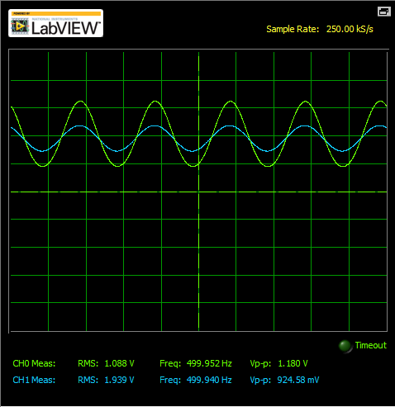

*Figure 5*

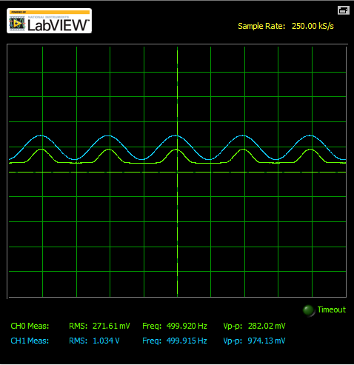

*Figure 6*

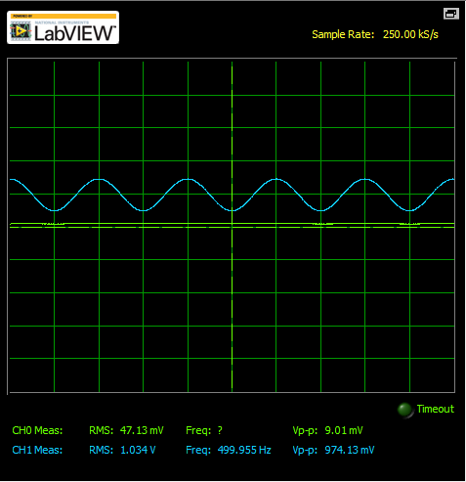

*Figure 7*

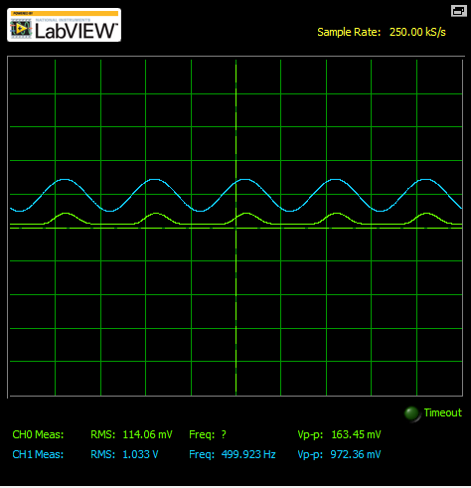

*Figure 8*

# **Step 4**

For Step 4, we used the Arbitrary Waveform Generator to create a square wave with 2 V of amplitude. The image of the input and output AM signals are shown in *Figure 9*.

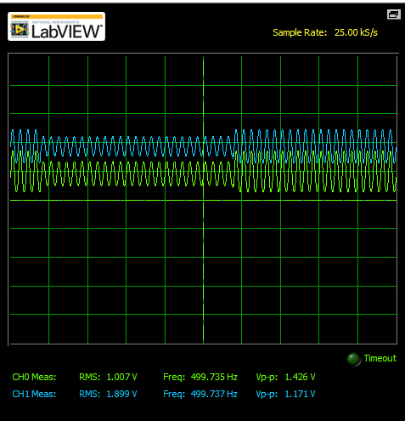

*Figure 9*

# **Step 5**

For Step 5, we repeated a similar process from Step 4, but this time instead of an AM signal it was a FM signal. We could see that the signal was being compressed. The screenshot of the graph obtained is shown in *Figure 10*.

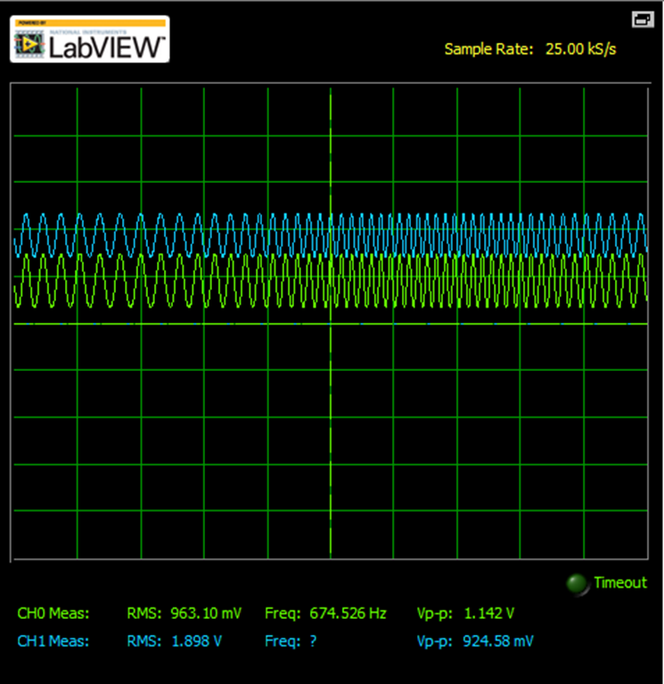

*Figure 9*

# **Conclusion**

In Conclusion, this lab was very interesting. This was our first lab with IR signals and it was very interesting to see how they work hands-on. The lab was a very good way of teaching us the basics of IR signals and how photo transistors receive those signals.